**Class Tasks**

**Task#1**

Create a form similar to the below one.

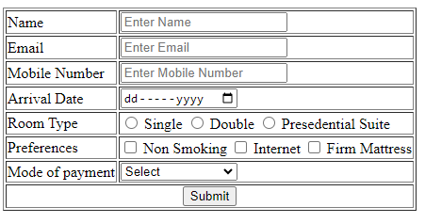

**Task#2**

You have to create the webpage similar to the below one.

